We will convert the Postgresql-database-diagram to STAR SCHEMA DIAGRAM

Example:

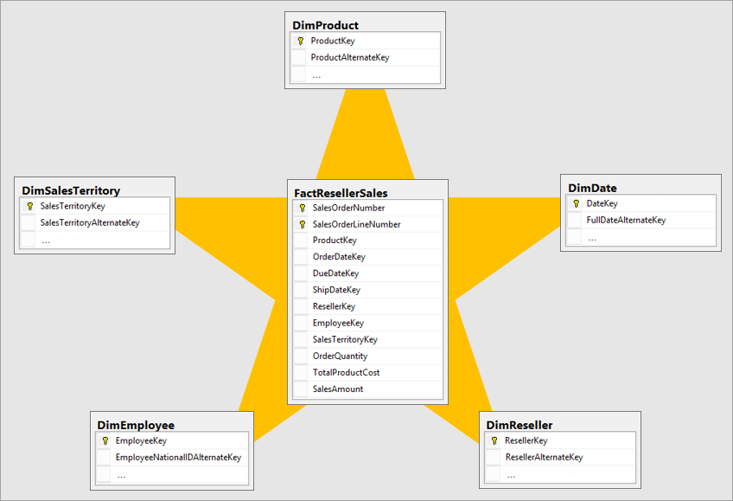

The facts tables are usually those tables around which the analysis is carried on.(In our case its sales/payment/revenue.)

Refer 01.Step document for the analysis topic.

Now there are multiple tables spread across the diagram we can combined few of the column from different tables to one table that gives similar information or that shares similar data.

Star Schema has been modeled in draw.io.

Now create the tables in database.

1.Open query tool on right clicking dvdrental database.

CREATE TABLE dimdate

(

date_key integer NOT NULL PRIMARY KEY,

date date NOT NULL,

year smallint NOT NULL,

quarter smallint NOT NULL,

month smallint NOT NULL,

day smallint NOT NULL,

week smallint NOT NULL,

is weekend boolean

);

Now you can check this table under Tables.

To check the information about dimDate table

select from information_schema.columns where table_name = 'dimdate'

If you do not want all the information than you can select the specific info like below

select column_name, data_type from information_schema.columns where table_name = 'dimdate'

CREATE TABLE dimcustomer

(

customer_key SERIAL PRIMARY KEY,

customer_id smallint NOT NULL,

first_name varchar(45) NOT NULL,

last_name varchar (45) NOT NULL,

email varchar (50),

address varchar (50) NOT NULL,

address2 varchar (50),

district varchar (20) NOT NULL,

city varchar (50) NOT NULL,

country varchar (50) NOT NULL,

postal_code varchar(10),

phone varchar (20) NOT NULL,

start_date date NOT NULL,

end_date date NOT NULL

);

CREATE TABLE dimmovie

(

movie_key integer NOT NULL PRIMARY KEY,

film_id integer NOT NULL,

title varchar (255) NOT NULL,

description varchar (200) NOT NULL,

release_year integer NOT NULL,

language_id smallint NOT NULL,

length smallint NOT NULL,

ratings varchar (10) NOT NULL,

special_features varchar (100) NOT NULL,

);

CREATE TABLE dimstore

(

store_key integer PRIMARY KEY,

store_id integer NOT NULL,

address varchar(50) NOT NULL,

address2 varchar (45),

district varchar (50),

city varchar (50) NOT NULL,

country varchar (50) NOT NULL,

postal_code varchar(10),

manager_first_name varchar (45) NOT NULL,

manager_last_name varchar (45) NOT NULL,

start_date date NOT NULL,

end_date date NOT NULL

);

CREATE TABLE factSales

(

sales_key SERIAL PRIMARY KEY,

date_key integer REFERENCES dimDate (date_key),

customer_key integer REFERENCES dimCustomer (customer_key),

movie_key integer REFERENCES dimMovie (movie_key),

store_key integer REFERENCES dimStore (store_key),

sales_amount numeric

);

Insert data into the above tables.

INSERT INTO dimdate

(date_key, date, year, quarter, month, day, week, is_weekend)

SELECT

DISTINCT (TO_CHAR (payment_date :: DATE, 'yyyMMDD') ::integer) as date_key, #the payment date is in timestamp format so to convert it to integer.

date (payment_date) as date,

EXTRACT (year from payment_date) as year,

EXTRACT (quarter FROM payment_date) AS quarter,

EXTRACT (month FROM payment_date) AS month,

EXTRACT (day FROM payment_date) AS day,

EXTRACT (week FROM payment_date) AS week,

CASE WHEN EXTRACT (ISODOW FROM payment_date) IN (6, 7) THEN true ELSE false END AS is_weekend #to select the days which is weekend ..Monday 1….Sunday 7

FROM payment;

INSERT INTO dimcustomer(customer_key,customer_id,first_name,last_name,email

,address,address2,district,city,country,postal_code,phone,start_date,end_date)

SELECT c.customer_id as customer_key,

c.customer_id,

c.first_name,

c.last_name,

c.email,

a.address,

a.address2,

a.district,

ci.city,

co.country,

a.postal_code,

a.phone,

now() AS start_date,

now() AS end_date

FROM customer c

JOIN address a ON (c.address_id = a.address_id)

JOIN city ci ON (a.city_id = ci.city_id)

JOIN country co ON (ci.country_id = co.country_id);

INSERT INTO dimmovie(movie_key,film_id,title,description,release_year,language_id,length,ratings, special_features)

SELECT f.film_id as movie_key,

f.film_id,

f.title,

f.description,

f.release_year,

f.language_id,

f.length,

f.rating,

f.special_features

FROM film f;

INSERT INTO dimstore(store_key,store_id,address,address2,district,city,country,postal_code,manager_first_name,manager_last_name,start_date,end_date)

SELECT s.store_id as store_key,

s.store_id,

a.address,

a.address2,

a.district,

ci.city,

co.country,

a.postal_code,

st.first_name as manager_first_name,

st.last_name as manager_last_name,

now() AS start_date,

now() AS end_date

FROM store s

JOIN staff st ON (s.manager_staff_id = st.staff_id)

JOIN address a ON (s.address_id = a.address_id)

JOIN city ci ON (a.city_id = ci.city_id)

JOIN country co ON (ci.country_id = co.country_id);

INSERT INTO factSales (date_key, customer_key, movie_key, store_key, sales_amount)

SELECT

DISTINCT (TO_CHAR (payment_date :: DATE, 'yyyMMDD') ::integer) as date_key,

p.customer_id as customer_key,

i.film_id as movie_key,

i.store_id as store_key,

p.amount as sales_amount

FROM payment p

JOIN rental r ON (p.rental_id = r.rental_id)

JOIN inventory i ON (r.inventory_id = i.inventory_id);

Query to see the data

SELECT f.title, EXTRACT (month FROM p.payment_date) as month, ci.city, sum (p.amount) as

FROM payment p

JOIN rental r ON (p.rental_id = r.rental_id)

JOIN inventory i ON (r.inventory_id = i.inventory_id)

JOIN film f ON (i.film_id = f.film_id)

JOIN customer c ON ( p.customer_id = c.customer_id)

JOIN address a ON (c.address_id = a.address_id )

JOIN city ci ON ( a.city_id = ci.city_id)

group by (f.title, month, ci.city)

order by f.title, month, ci.city, revenue desc;

similarly with other tables we can use the above query.Difference between this stars schema model queries and 3NF model query(query which we used earlier in previous document) is that the star schema runs faster.